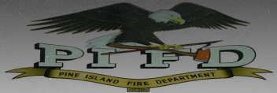 Pine Island Area Fire Association

315 South Main Street

Pine Island, MN 55963-8605

28 February, 2025

To: Oronoco Township

Subject: Pine Island Area Fire District 2025 Dues Invoice

Oronoco Township’s total dues for the Pine Island Fire District for 2024 fire department charges are $108,584. Please make a check payable to Pine Island Fire Association for **$54,292** and mail it to me by the end of April. The balance of $54,292 can be held in reserve for the Fire Association until such time that a major equipment needs to be made.

Kim Stanton

12649 Tiffany Court

Burnsville, MN 55337-3487

If you have any questions, you can call me at 507-577-8518 or e-mail, [kims4799@gmail.com](mailto:kims4799@gmail.com) . Thank you.

Sincerely,

Kim Stanton Treasurer

Pine Island Area Fire District

507-577-8518