**ARTICLE IX - RIVER CORRIDOR OVERLAY DISTRICT**

**Section 9.00 STATUTORY AUTHORIZATION**

This river corridor ordinance is adopted pursuant to the authorization and policies contained in [Minnesota Statutes, Chapter 103F](https://www.revisor.mn.gov/statutes/?id=103F), [Minnesota Rules, Parts 6120.2500 - 6120.3900](https://www.revisor.mn.gov/rules/?id=6120), and the planning and zoning enabling legislation in Minnesota Statutes Chapter [462](https://www.revisor.mn.gov/statutes/?id=462).

**Section 9.01 PURPOSE AND INTENT**

## The Legislature of Minnesota has delegated responsibility to local governments of the state to regulate the subdivision, use, and development of the shorelands of public waters and thus preserve and enhance the quality of surface waters, conserve the economic and natural environmental values of shorelands, and provide for the wise use of waters and related land resources. This responsibility is hereby recognized by Oronoco Township.

## The Township finds that the uncontrolled use of shorelands in the Township affects the public health, safety, and general welfare by contributing to pollution of public waters and potentially decreasing property, public, and natural resource values. It is the intent and purpose of this ordinance to:

1. Designate suitable land use intensity and density adjacent to public water bodies.

2. Regulate lot size, buildable area, and placement that are suitable for building sites.

3. Regulate the alteration of shorelands along public waters.

4. Regulate alterations of the natural vegetation and the natural topography along shorelands.

5. Conserve natural resources and maintain a high standard of environmental quality.

6. Preserve and enhance the quality of surface waters.

7. Preserve the economic, natural, and environmental values of shorelands.

8. Maintain water quality and reduce flooding and erosion.

**Section 9.02 APPLICABILITY**

The “River Corridor Overlay District” shall be an overlay district and shall be superimposed on all zoning classifications in the designated overlay area. The River Corridor Overlay District shall correspond to any/all shorelands of the public water bodies and water courses as classified in this Ordinance. The standards contained in the River Corridor Overlay District shall be in addition to any other requirements set forth in the Township’s Zoning Ordinance. If the District standards are conflicting with the Zoning Ordinance, the more restrictive standards shall apply.

This Article IX applies to all subdivisions, site development plan approvals, individual building permits, or grading projects that would alter the landscape by more than 10 cubic yards within steep slopes, shore and bluff impact zones, and more than 50 cubic yards outside of steep slopes, shore and bluff impact zones within the River Corridor Overlay Zone.

River Corridor Overlay Zone includes the following area: Land located within 2,500 feet from the ordinary high water level or the landward extent of a flood plain designed by ordinance thatis within public water within Oronoco Township that has been classified as consistent with the criteria found in Minnesota Regulations, Part 6120.3300, and the Protected Waters Inventory Map for Olmsted County, Minnesota for the following bodies of water:

1. The South Fork of the Zumbro River; and
2. The Middle Fork of the Zumbro River; and
3. The South Branch Middle Fork Zumbro River; and
4. Lake Zumbro

A graphical representation of this area can be found in Section 9.14, Map 1.2 River Corridor Overlay Zone Areas. However, this map is only a representation of the area. If the map conflicts with the text described above, the text shall prevail and control.

**Section 9.03 ENFORCEMENT**

Oronoco Township is responsible for the administration and enforcement of this ordinance. Any violation of the provisions of this ordinance or failure to comply with any of its requirements (including violations of conditions and safeguards established in connection with grants of variances, interim uses or conditional uses) constitutes a misdemeanor and is punishable as defined by law. Violations of this ordinance can occur regardless of whether or not a permit is required for a regulated activity.

**Section 9.04 SEVERABILITY**

If any section, clause, provision, or portion of this ordinance is adjudged unconstitutional or invalid by a court of competent jurisdiction, the remainder of this ordinance shall not be affected thereby.

**Section 9.05 ABROGATION AND GREATER RESTRICTIONS**

It is not intended by this ordinance to repeal, abrogate, or impair any existing easements, covenants, or deed restrictions. However, where this ordinance imposes greater restrictions, the provisions of this ordinance shall prevail. All other ordinances inconsistent with this ordinance are hereby repealed to the extent of the inconsistency only.

**Section 9.06 RELATIONSHIP TO OTHER STANDARDS**

The regulations contained in this section of the Oronoco Township Code are in addition to and not in lieu of other regulations contained in other sections of the Oronoco Township Code, Olmsted County, or other State of Minnesota Statutes and Rules. Where the standards contained in any other laws are inconsistent with standards of this ordinance, the more restrictive standard shall apply.

**Section 9.07 DEFINITIONS**

Definitions found in Article II, Section 2.00 of the Oronoco Township Zoning Ordinance and the following additional definitions:

Buffer. A vegetative feature as defined by Minnesota Statues, Section 103F.48.

Building Line. A line parallel to a lot line or the ordinary high-water level at the required setback beyond which a structure may not extend.

Community Wastewater Treatment System. Pipelines or conduits, pumping stations, and force main, and all other construction, devices, appliances, or appurtenances used for conducting sewage or other wastes to a point of ultimate disposal.

Duplex, Triplex, and Quad. A dwelling structure on a single lot, having two, three, and four units, respectively, attached by common walls and each unity equipment with separate sleeping, cooking, eating, living and sanitation facilities.

Extractive Use. The use of land for surface or subsurface removal of sand, gravel, rock, industrial minerals, other nonmetallic minerals, and peat not regulated under Minnesota Statutes, Section 93.44 to 93.51.

Heritage Tree. A heritage tree is typically a large, individual tree with unique value, which is considered irreplaceable. The major criteria for heritage tree designation are age, rarity, and size, as well as aesthetic, botanical, ecological, and historical value

Impervious Surface. A constructed hard surface that prevents or retards entry of water into the soil and causes water to run off the surface in greater quantities and at an increased rate of flow than prior to development, including rooftops, decks, sidewalks, patios; swimming pools, parking lots, concrete, asphalt, gravel driveways, or permeable pavers; and other similar surfaces

Planned Unit Development (PUD). A type of development characterized by a unified site design for a number of dwelling units or dwelling sites on a parcel, whether for sale, rent or lease and also usually involving clustering of these units or sites to provide areas of common open space, density increased, and a mix of structure types and land uses, as defined in the Floodplain and Shoreland Ordinance.

Shore Recreation Facilities. Swimming areas, docks, watercraft mooring areas and launching ramps and other water recreation facilities.

Stage Increase. Any increase in the water surface elevation during the one-percent annual chance flood caused by encroachment on the floodplain.

Watercourse. A channel in which a flow of water occurs either continuously or intermittently in a definitive direction. The term applies to either natural or artificially constructed channels.

**Section 9.08 ADMINISTRATION**

1. **Administration**: The purpose of this Section is to identify administrative provisions to ensure the ordinance is administered consistently with its purpose. The issuance of any variances from the requirements of any official control contained in this ordinance, shall be in accordance with Article IV, Section 4.08 of the Oronoco Township Zoning Ordinance.
2. **Permits:** Underlying zoning uses and standards of underlying zoning districts apply except where standards of this ordinance are more restrictive. A conditional use permit shall be required for the construction of buildings or building additions, including construction of decks, the installation and/or alteration of sewage treatment systems, and any grading activities as defined in Section 9.02, on properties within the River Corridor Overlay Zone to ensure that all Development Standards contained in Section 9.11 are satisfied. In processing any application for a conditional use permit, the Township shall evaluate the potential impacts to the river corridor and if negative impacts are found, require conditions to mitigate the impacts that are related to and proportional to the impacts.
3. **Application Materials:** Application for a conditional use permit and other zoning applications such as variances shall be made to Oronoco Township on the forms provided. The application shall include the necessary information as required by the Township’s Zoning Ordinance and such other additional information as may be requested by the Township so that the Township can evaluate how the application complies with the provisions of this ordinance.
4. **Process:** See Article IV, Section 4.02, Conditional Use Process and Section 4.08, Variance Process

**Section 9.09 NONCONFORMITIES**

All legally established nonconformities as of the date of this ordinance may continue, but will be managed according to Minnesota Statutes Section 462.357 Subd. 1e and its successor statutes, and Article I, Section 1.28 of the Oronoco Township Zoning Ordinance**.**

**Section 9.10 BUILDING SETBACK**

Building setbacks to follow Olmsted County’s Shoreland Ordinance standards. However, in no case shall the primary building setback be less than 100 feet for all parcels within the River Corridor Overlay Zone.

**Section 9.11 ZONING PROCEDURE**

The underlying zoning districts within the River Corridor Overlay District shall correspond to the Township’s Official Zoning Map.

**Section 9.12 DEVELOPMENT STANDARDS**

1. **Erosion/Grading stabilization:** 
   1. Grading and filling activities must comply with the Olmsted County Floodplain and Shoreland Ordinance and this ordinance whichever provision is more restrictive.
   2. Intensive vegetation clearing in the river corridor overlay zone and on steep slopes is prohibited. However, the removal of trees, limbs, or branches that are dead, diseased, dying, or pose safety hazards is allowed.
   3. All topsoil that is removed during construction must be stockpiled on site and then used after construction in areas where topsoil is required.
2. **Wastewater Management and Shared Wells:** 
   1. All lots within a clustered development with lot sizes smaller than 2 acres shall be served by CSTS with a common collection system and shared wells that must follow all standards within Chapter 3200 and 3400 of the Olmsted County Code of Ordinances.
   2. All lots within a clustered development with lot sizes smaller than 2 acres shall submit a CSTS Management Plan which must follow all standards within Oronoco Township Code and be submitted with the application.
   3. The CSTS Management Plan, if required, shall show the location(s) of the CSTS and all shared well(s) locations and provide detailed plans and specifications provided for the proposed CSTS and shared well(s).
   4. No direct piping will be allowed into MnDNR waterways as defined in Section 6.01 in the Olmsted County Shoreland Ordinance which is consistent with the criteria found in Minnesota Regulations, Part 6120.3300, and the Protected Waters Inventory Map for Olmsted County, Minnesota.
3. **Common Collection System**:
   1. If a CSTS is proposed to be used, access to the treatment sites shall be provided by constructing a service road within a designated access easement(s).
   2. If a CSTS is proposed to be used, upon completion of the CSTS, the ownership and maintenance of the CSTS shall be the responsibility of Peoples Cooperative Service (PCS) of Olmsted County or similar agency approved by the Township that is equipped, staffed and properly licensed to operate such a system (Agency). Applicant shall provide evidence to the satisfaction of the Township that PCS or similar Agency has agreed to own, operate and maintain the CSTS.
   3. Shared well maintenance will be managed by the homeowner and must meet or exceed all applicable requirements of the Olmsted County Water Well and Water Supply Ordinance, and amendments thereto.
4. **Public Improvement:** Roadways within subdivisions shall either be constructed as public roadways in accordance with the applicable standards adopted by Oronoco Township or private as approved by the Town Board as part of the approved PUD.
5. **Open Space Conservation Areas (OSCA):** The purpose of OSCA is to identify environmentally sensitive areas that are wooded, prairie, oak savanna, steep slopes, erodible soils, wetlands, or general open spaces areas that will be preserved as permanent open space. These areas should include, if applicable, biologically significant, unique, and/or rare natural features. The preservation of amenities such as water detention and sedimentation areas, common drain fields, trails and recreational uses shall be considered in the calculation of open space as part of the OSCA area, as part of the development.
   1. No construction or clearing shall be allowed in an OSCA area.
   2. The minimum OSCA areas required with defined development tiers are defined in Section 9.13, Table 1.1, River Corridor Tier Standards.
   3. OSCA areas must be approved by the Town Board as part of a clustered development submittal package or with the building permit.
   4. An exhibit showing the OSCA/No Build area as part of the overall site plan is required to depict the total lot area and total OSCA area in size and percentage.
6. **Building Pads:** A buildable area or building pad must be identified for each lot showing a large enough area to allow for the intended building to be constructed and meet all zoning standard setbacks but cannot be larger than 5,000 square feet. No building pad can be located within 50 feet of steep slopes or wooded/woodland areas. Lot owners shall take into consideration the effect building placement might have on wooded or steep slope areas. (See Definition Article II, Section 2.00) During review, the Township will use all the required materials from the submittal to evaluate building pad sites. Only approved building pad areas can obtain a building permit.

**G.** **Forestry** **Management Plan:** For all clustered developments within the River Corridor Overlay Zone that have Wooded or Woodland Areas (See Section 2.00), a Forestry Management Plan shall be completed that includes all trees, highlighting heritage trees and those with special ecological and/or aesthetic value with the aim to protect them. The plan shall be submitted with the conditional use preliminary plat and plans and implemented by all homeowners to preserve and protect the existing woodland, visibility buffer, and OSCA areas. The plan must be written by a DNR Forester or DNR approved plan writer. A list of approved plan writers will be provided by the Township. For areas that are in native prairie or oak savanna, a land management plan shall be completed by a qualified professional ecologist, restoration ecologist, or land management consultant.

**H. Turf Management:** For all clustered developments within the River Corridor Overlay Zone, a TurfManagement Plan(s) shall be required and shall be submitted with the preliminary plat application. The approved Turf Management Plan shall be incorporated within the Protective Covenants for all clustered developments and implemented by all homeowners. The Turf Management Plan shall specifically address fertilization, mowing, watering, and pesticide application procedures for lawns and gardens to minimize potential pollution and be submitted by a registered or licensed landscape architect. Fertilizer and pesticide runoff into surface waters must be minimized through use of vegetation, topography or both. Maximum turf areas are defined per tier in Section 9.13 Table 1.1, River Corridor Tier Standards. All State Statutes and best management practices must be incorporated into the Turf Management Plan.

**I.** **Agricultural Protection:** For all clustered developments within the River Corridor Overlay Zone that are adjacentto active agricultural operations that are expected to continue on an indefinite basis, a Township approved notice shall be recorded at developer’s expense against all the properties within the clustered development that such uses may create unpleasant odors, dust, noise, and other similar annoyances.

**J.** **Visibility Buffer**: A Visibility buffer protects the water resources of the state from runoff pollution; stabilizes shores, and banks; protects riparian corridors, improves root stabilization, rainfall erosion, and improves soils.

1. 50 percent of the lot frontage adjacent to all waterways in the River Corridor Overlay Zone must plan, construct, and maintain a visibility buffer that will consist of native perennial vegetation, excluding invasive plants and noxious weeds.

2. The visibility buffer will be a minimum of 30 feet in width and will include a continuous buffer of perennially rooted native vegetation along with a minimum of one (1) 1-inch caliper tree every 20 feet for the length of the visibility buffer area. This requirement can be evaluated based on specific site needs and final minimum width determined during review. All trees must be planted, maintained, and protected from deer/rabbits for at least five years. See suggested list of perennial vegetation options.

3. Approved tree species can be obtained by the Oronoco Township on its website.

4. A visibility buffer plan must be submitted with the preliminary plat and plans for review and approval by the Town Board.

**K.** **Steep Slopes:** Any areas defined as a steep slope (See Section 2.00) that are located with the River Corridor Overlay Zone must be identified on concept and pre-development plans along with a concept erosion control plan designed to maintain erodible soils through plantings and/or best management engineering practices and shall be verified by a qualified resource agency such as the Soil and Water Conservation District, DNR, MPCE, watershed district, or the Zoning Administrator

**L.** **Wetlands**: NWI defined wetlands must be identified on concept and pre-development plans and delineated by a qualified wetland specialist on preliminary plans and avoided from development.

**M.** **Uses along Lake Zumbro**: Article IX is incorporating by reference, Chapter 3750-Floodplain and Shoreland Ordinance Table 6-3 of Land Use Summary – Lakes for Recreational Development Lakes as amended. The uses listed below are more restrictive than referenced Table 6-3.

|  |  |
| --- | --- |
| **Land Uses if allowed by underlying zoning** | **Recreational Development** |
| Single residential | P |
| Duplex, triplex, quad residential | P (*C for RCOZ) |
| Residential PUD | C |
| Water-dependent commercial As accessory to a residential planned unit development | C |
| Commercial | P (C for RCOZ) |
| Commercial PUD - Limited expansion of commercial PUDs involving up to six additional dwelling units or sites may be allowed as a permitted use provided the provisions of Section5.04 of these ordinances are satisfied. | C |
| Guest Cottages | N |
| Parks & historic sites | C |
| Public, semipublic | P |
| Industrial | C (N for RCOZ) |
| Agricultural, cropland and pasture | P |
| Agriculture feedlots – New | N |
| Agricultural feedlots – Expansion or resumption of existing | C |
| Forest management | P |
| Forest land conversion | C (N for RCOZ) |
| Extractive use | C (N for RCOZ) |
| Mining of metallic mineral and peat | P (N for RCOZ) |
| Commercial Solar and Wind – Alternative Energy Uses | (N in RCOZ) |
| **P= Permitted C= Conditional Use N = Not Allowed** | |

*\* 1 - Must show that housing type/size works within the RCO property without negative impacts to the site, surrounding area, and Zumbro River.*

**N.** **Uses along Zumbro River**: Article IX is incorporating by reference, Chapter 3750-Floodplain and Shoreland Ordinance Table 6-4 of Summary of Rivers and Streams for Transition River and Streams as amended. The uses listed below are more restrictive than referenced Table 6-4.

|  |  |
| --- | --- |
| **Land Uses if allowed by underlying zoning** | **Transition** |
| Single residential | **P** |
| Duplex, triplex, quad residential | P (*C for RCOZ) |
| Residential PUD | **C** |
| Water-dependent commercial As accessory to a residential planned unit development | **C** |
| Commercial | **C** |
| Commercial PUD - Limited expansion of commercial PUDs involving up to six additional dwelling units or sites may be allowed as a permitted use provided the provisions of Section  5.04 of these ordinances are satisfied. | **C** |
| Guest Cottages | N |
| Parks & historic sites | **C** |
| Public, semipublic | **C** |
| Industrial | N |
| Agricultural, cropland and pasture | P |
| Agriculture feedlots – New | N |
| Agricultural feedlots – Expansion or resumption of existing | C |
| Forest management | P |
| Forest land conversion | C (N for RCOZ) |
| Extractive use | C (N for RCOZ) |
| Mining of metallic mineral and peat (NEW) | P (N for RCOZ) |
| Commercial Solar and Wind – Alternative Energy Uses | (N in RCOZ) |
| **P= Permitted C= Conditional Use N = Not Allowed** | |

*\* 1 - Must show that housing type/size works within the RCO property without negative impacts to the site, surrounding area, and Zumbro River.*

**Section 9.13**

**Table 1.1 River Corridor Tier Standards:**

|  |  |  |  |  |  |  |  |  |
| --- | --- | --- | --- | --- | --- | --- | --- | --- |
|  | **DU/ Ac** | **OPCA AREAS** | **Maximum**  **Turf**  **Allowed** | **Site Clearing** | **Visibility Buffer from Water** | **Maximum Impervious Surface** | **Zone** | **BFE** |
| **Shore Impact**  **Zone**  **(50’) Setback** | N/A | 100% | 25% | Not allowed | 50% of lot width facing waterway must be screened with a visibility buffer | 0% | N/A | N/A |
| **Stream/River**  **Setback (300’)** | 1 lot per 5 Ac. | 75% | 25% | Not allowed |  | 25% | RA  1 unit per 5 ac. | 2’ above BFE 3’ for critical facilities |
| **River Corridor Setback (1000’)** | 1 lot per 5 Ac. | 50% | 50% | Not allowed |  | 25% | RA  1 unit per 5 ac. | 2’ above BFE 3’ for critical facilities |
| **Extended Resource Protection** Area **(2500’)** | 1 lot per  5 Ac.  2.5 Ac. *-*1* | 25% | 75% | 25% Allowed | N/A | 75% | RA  1 unit per 5 ac. | 2’ above BFE 3’ for critical facilities |

*\*1 – To achieve a 2.5 units per acre density with a clustered development style, a Special District process is required. A shared community OSCA (see section E) covering 40% of the acres will be required in all clustered developments.*

**Section 9.14**

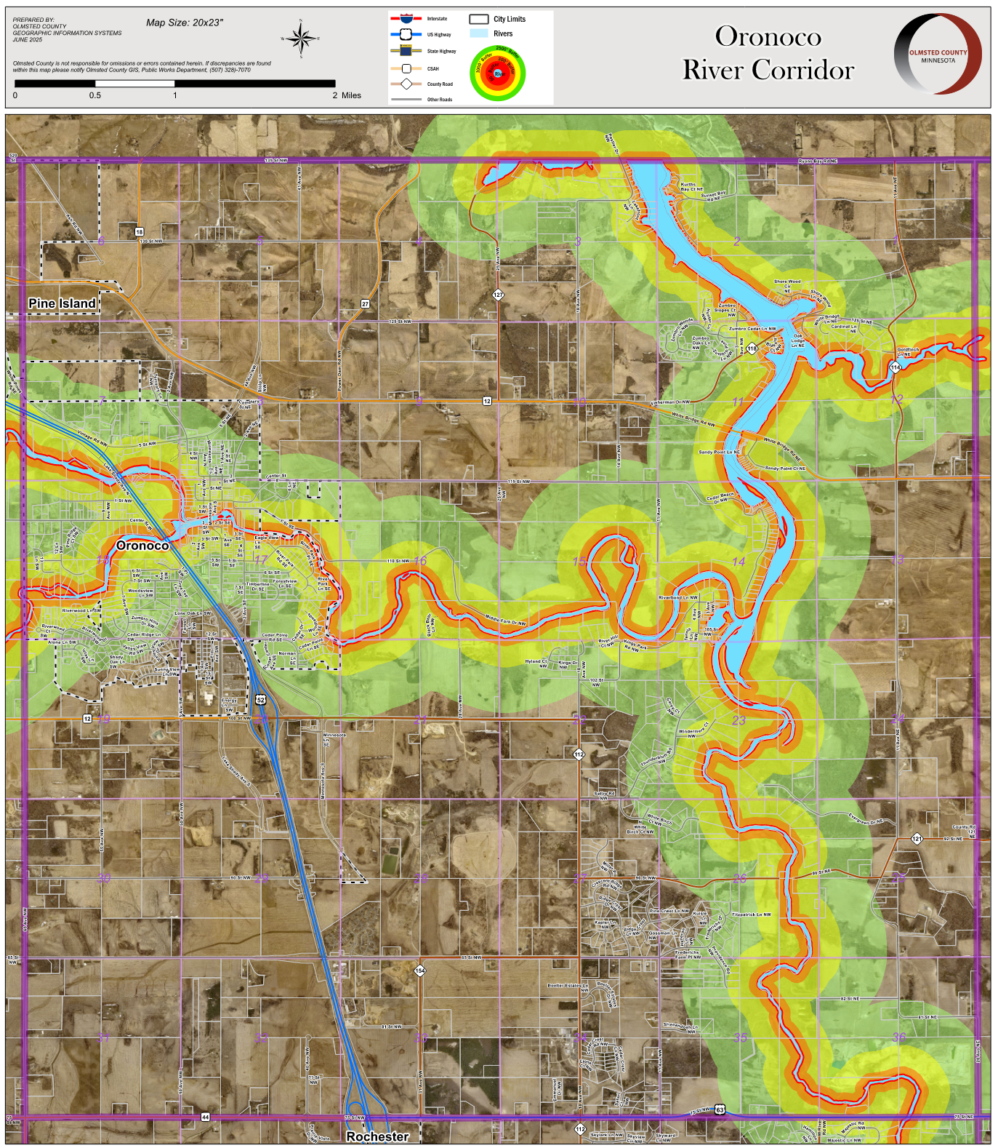**Map 1.2 River Corridor Overlay Zone Areas**